Adrien Protzel

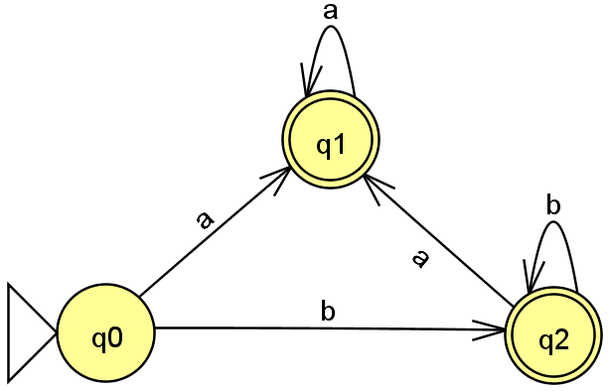

1. Accept strings that are either “a” and strings of any number of “b” followed by any number of “a”.
2. -
3. -
4. 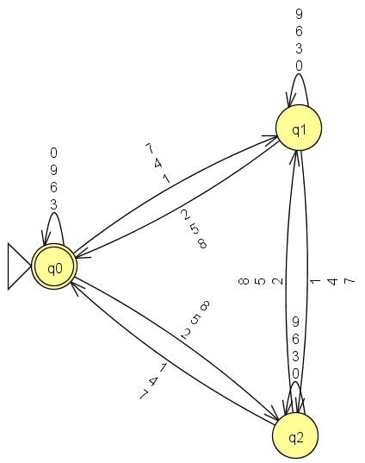Q={q0, q1, q2, q3}

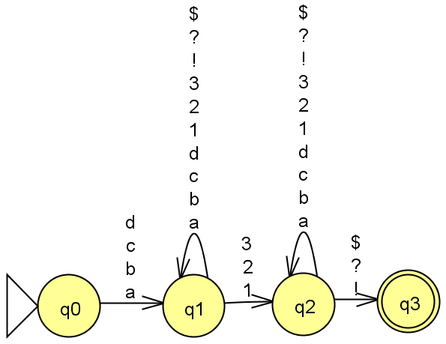Σ={0,1}

F={q1, a3}

S=q0

| δ | 0 | 1 |
| --- | --- | --- |
| q0 | q1 | q3 |
| q1 | q1 | q2 |
| q2 | q2 | q2 |
| q3 | q1 | q3 |

$L={\{o}^{n}:n≥1\}∪{}{\{1}^{m}o^{k}:m≥1,k≥0\}$

1 cannot come after 0’s.

1. Because L is regular then there exists a DFA

A DFA must accept its complement if its final states are flipped.

{aa,baaaa,...}

{a,bab,...}